GOVT POLYTECHNIC COLLEGE BHIKHIWIND(TARN TARAN)


A MINER PROJECT REPORT ON BOOKS RECORDS

IN C++

COMPUTER ENGINEERING

IN

5th SEMESTER

SUBMITTED TO: SUBMITTED BY:
ER. Amarjit singh Amarjit kaur Reg.No.227456 Varinderdeep Reg. No.226684
Sandeep kaur Reg.No.206049
Komalpreet Reg.No.206676

TABLE OF CONTENTS

Sr. no. | NAME
1. | Acknowledgement
2. | Abstract of project
3. | Introduction of c++
4. | About of project
5. | Working description of project
6. | Header files and their purpose
7. | Files generated and coding
8. | Outputs
9. | Conclusion
10. | Scope of future
11. | Bibliography

ACKNOWLEDGEMENT

We have the honors to express our deep sense of gratitude to our project guide Er. Amarjit Singh, Lecturer Govt . Pollytechnic college,Bhikhiwind. We made this project in miner project on c++ language.it would be our utmost Pleasure to express our sincere thanks to our miner project teacher Mr. Amarjit singh in providing a helping hand in this project.His patience,Creativity and immense knowledge that he shared with our proved highly beneficial to our and made my project file both possible and successful.

SUBMITTED BY:
Amarjit kaur Reg.No.227456 Varinderdeep Reg. No.226684
Sandeep kaur Reg.No.206049
Komalpreet Reg.No.206676

ABSTRACT

This project is used to keep the record of books in the library.The main purpose of this project is

To display the data of books in library - in this all data of books is represent.

Display the list of issue books- in this all data of issue books is represent.

Enter and display the record of student-in this enter data of student represent.

Search the record of student-in this we search about student.

Exit- this option is used to the exit of library project.

INTRODUCTION OF C++
During the 1980s and into the 1990s, an explosive growth in object-oriented technology began with the introduction of the Smalltalk language. Object-Oriented Programming (OOP) began to replace the more traditional structured programming techniques. This explosion led to the development of languages which support programming with objects. Many new object-oriented programming languages appeared: Object-Pascal, Modula-2, Mesa, Cedar, Neon, Objective-C, LISP with the Common List Object System (CLOS), and, of course, C++. Although many of these languages appeared in the 1980s, many ideas of OOP were taken from Simula-67. Yes! OOP has been around since 1967.
C++ originated with Bjarne Stroustrop. In the simplest sense, if not the most accurate, we can consider it to be a better C. Although it is not an entirely new language, C++ represents a significant extension of C abilities. We might then consider C to be a subset of C++. C++ supports essentially every desirable behavior and most of the undesirable ones of its predecessor, but provides general language improvements as well as adding OOP capability. This tutorial is a collection of lectures to be held in the on-line course Introduction to Object-Oriented Programming Using C++ . In this course, object-orientation is introduced as a new programming concept which should help you in developing high quality software. Object-orientation is also introduced as a concept which makes developing of projects easier. However, this is not a course for learning the C++ programming language. If you are interested in learning the language itself, you might want to go through other tutorials, such as C++: Annotations by Frank Broken and Karel Kubat. In this tutorial only those language concepts that are needed to present coding examples are introduced. And what makes object-orientation such a hot topic? To be honest, not everything that is sold under the term of object-orientation is really new. For example, there are programs written in procedural languages like Pascal or C which use object-oriented concepts. But there exist a few important features which these languages won't handle or won't handle very well, respectively. Some people will say that object-orientation is ``modern''. When reading announcements of new products everything seems to be ``object-oriented''. ``Objects'' are everywhere. In this tutorial we will try to outline characteristics of object-orientation to allow you to judge those object-oriented products.
The designers of C++ wanted to add object-oriented mechanisms without compromising the efficiency and simplicity that made C so popular. One of the driving principles for the language designers was to hide complexity from the programmer, allowing her to concentrate on the problem at hand. Because C++ retains C as a subset, it gains many of the attractive features of the C language, such as efficiency, closeness to the machine, and a variety of built-in types. A number of new features were added to C++ to make the language even more robust, many of which are not used by novice programmers. By introducing these new features here, we hope that you will begin to use them in your own programs early on and gain their benefits. Some of the features we will look at are the role of constants, inline expansion, references, declaration statements, user defined types, overloading, and the free store. Most of these features can be summarized by two important design goals: strong compiler type checking and a user-extensible language. By enforcing stricter type-checking, the C++ compiler makes us acutely aware of data types in our expressions. Stronger type checking is provided through several mechanisms, including: function argument type checking, conversions, and a few other features we will examine below.
C++ also enables programmers to incorporate new types into the language, through the use of classes. A class is a user-defined type. The compiler can treat new types as if they are one of the built-in types. This is a very powerful feature. In addition, the class provides the mechanism for data abstraction and encapsulation, which are key to object-oriented programming. As we examine some of the new features of C++ we will see these two goals resurface again and again.
BASIC CONCEPT OF OBJECT ORIENTED PROGRAMMING
Class
A class is an actual representation of an ADT. It therefore provides implementation details for the data structure used and operations. We play with the ADT Integer and design our own class for it:
class Integer {
attributes:
int i

methods:
setValue(int n)
Integer addValue(Integer j)
}
In the example above as well as in examples which follow we use a notation which is not programming language specific. In this notation class {...} denotes the definition of a class. Enclosed in the curly brackets are two sections attributes: and methods: which define the implementation of the data structure and operations of the corresponding ADT. Again we distinguish the two levels with different terms: At the implementation level we speak of ``attributes'' which are elements of the data structure at the ADT level. The same applies to ``methods'' which are the implementation of the ADT operations.
Abstract Classes
With inheritance we are able to force a subclass to offer the same properties like their superclasses. Consequently, objects of a subclass behave like objects of their superclasses.
Sometimes it make sense to only describe the properties of a set of objects without knowing the actual behaviour beforehand. In our drawing program example, each object should provide a method to draw itself on the drawing area. However, the necessary steps to draw an objects depends on its represented shape. For example, the drawing routine of a circle is different from the drawing routine of a rectangle.

Objects
C++ introduces object-oriented (OO) features to C. It offers classes, which provide the four features commonly present in OO (and some non-OO) languages: abstraction, encapsulation, inheritance, and polymorphism. Objects are instances of classes created at runtime. The class can be thought of as a template from which many different individual objects may be generated as a program runs.
Encapsulation
Encapsulation is the hiding of information in order to ensure that data structures and operators are used as intended and to make the usage model more obvious to the developer. C++ provides the ability to define classes and functions as its primary encapsulation mechanisms. Within a class, members can be declared as either public, protected, or private in order to explicitly enforce encapsulation. A public member of the class is accessible to any function. A private member is accessible only to functions that are members of that class and to functions and classes explicitly granted access permission by the class ("friends"). A protected member is accessible to members of classes that inherit from the class in addition to the class itself and any friends.
The OO principle is that all of the functions (and only the functions) that access the internal representation of a type should be encapsulated within the type definition. C++ supports this (via member functions and friend functions), but does not enforce it: the programmer can declare parts or all of the representation of a type to be public, and is allowed to make public entities that are not part of the representation of the type. Because of this, C++ supports not just OO programming, but other weaker decomposition paradigms, like modular programming.
It is generally considered good practice to make all data private or protected, and to make public only those functions that are part of a minimal interface for users of the class. This hides all the details of data implementation, allowing the designer to later fundamentally change the implementation without changing the interface in any way.
Inheritance
Inheritance allows one data type to acquire properties of other data types. Inheritance from a base class may be declared as public, protected, or private. This access specifier determines whether unrelated and derived classes can access the inherited public and protected members of the base class. Only public inheritance corresponds to what is usually meant by "inheritance". The other two forms are much less frequently used. If the access specifier is omitted, a "class" inherits privately, while a "struct" inherits publicly. Base classes may be declared as virtual; this is called virtual inheritance. Virtual inheritance ensures that only one instance of a base class exists in the inheritance graph, avoiding some of the ambiguity problems of multiple inheritance.
Multiple inheritance is a C++ feature sometimes considered controversial. Multiple inheritance allows a class to be derived from more than one base class; this can result in a complicated graph of inheritance relationships. For example, a "Flying Cat" class can inherit from both "Cat" and "Flying Mammal". Some other languages, such as Java or C#, accomplish something similar (although more limited) by allowing inheritance of multiple interfaces while restricting the number of base classes to one (interfaces, unlike classes, provide only declarations of member functions, no implementation or member data). Interfaces and abstract classes in Java and C# can be approximated in C++ as a class containing only function declarations, often known as an abstract base class or "ABC." Programmers preferring the Java/C# model of inheritance can choose to inherit only one non-abstract class, although in this case the declared member functions of the abstract base classes must be explicitly defined and cannot be inherited. Polymorphism
Polymorphism enables one common interface for many implementations, and for objects to act differently under different circumstances.
C++ supports several kinds of static (compile-time) and dynamic (run-time) polymorphisms. Compile-time polymorphism does not allow for certain run-time decisions, while run-time polymorphism typically incurs a performance penalty.
Static polymorphism
Function overloading allows programs to declare multiple functions having the same name (but with different arguments). The functions are distinguished by the number and/or types of their formal parameters. Thus, the same function name can refer to different functions depending on the context in which it is used. The type returned by the function is not used to distinguish overloaded functions.
When declaring a function, a programmer can specify default arguments for one or more parameters. Doing so allows the parameters with defaults to optionally be omitted when the function is called, in which case the default arguments will be used. When a function is called with fewer arguments than there are declared parameters, explicit arguments are matched to parameters in left-to-right order, with any unmatched parameters at the end of the parameter list being assigned their default arguments. In many cases, specifying default arguments in a single function declaration is preferable to providing overloaded function definitions with different numbers of parameters.
Templates in C++ provide a sophisticated mechanism for writing generic, polymorphic code. In particular, through the Curiously Recurring Template Pattern it's possible to implement a form of static polymorphism that closely mimics the syntax for overriding virtual functions. Since C++ templates are type-aware and Turing-complete they can also be used to let the compiler resolve recursive conditionals and generate substantial programs through template metaprogramming.
Dynamic polymorphism
C++ also provides a dynamic_cast operator, which allows the program to safely attempt conversion of an object into an object of a more specific object type (as opposed to conversion to a more general type, which is always allowed). This feature relies on run-time type information (RTTI). Objects known to be of a certain specific type can also be cast to that type with static_cast, a purely compile-time construct which is faster and does not require RTTI.
Virtual member functions
Ordinarily when a function in a derived class overrides a function in a base class, the function to call is determined by the type of the object. A given function is overridden when there exists no difference, in the number or type of parameters, between two or more definitions of that function. Hence, at compile time it may not be possible to determine the type of the object and therefore the correct function to call, given only a base class pointer; the decision is therefore put off until runtime. This is called dynamic dispatch. Virtual member functions or methods allow the most specific implementation of the function to be called, according to the actual run-time type of the object. In C++, this is commonly done using virtual function tables. If the object type is known, this may be bypassed by prepending a fully qualified class name before the function call, but in general calls to virtual functions are resolved at run time.
In addition to standard member functions, operator overloads and destructors can be virtual. A general rule of thumb is that if any functions in the class are virtual, the destructor should be as well. As the type of an object at its creation is known at compile time, constructors, and by extension copy constructors, cannot be virtual. Nonetheless a situation may arise where a copy of an object needs to be created when a pointer to a derived object is passed as a pointer to a base object. In such a case a common solution is to create a clone() (or similar) function and declare that as virtual. The clone() method creates and returns a copy of the derived class when called.
A member function can also be made "pure virtual" by appending it with = 0 after the closing parenthesis and before the semicolon. Objects cannot be created of a class with a pure virtual function and are called abstract data types. Such abstract data types can only be derived from. Any derived class inherits the virtual function as pure and must provide a non-pure definition of it (and all other pure virtual functions) before objects of the derived class can be created. A program that attempts to create an object of a class with a pure virtual member function or inherited pure virtual member function is ill-formed.
MESSAGE---[Definition (Message) A message is a request to an object to invoke one of its methods. A message therefore contains
the name of the method and
the arguments of the method.
Consequently, invocation of a method is just a reaction caused by receipt of a message. This is only possible, if the method is actually known to the object.
Definition (Method) A method is associated with a class. An object invokes a method as a reaction to receipt of a message.
Operators and operator overloading
C++ provides more than 30 operators, covering basic arithmetic, bit manipulation, indirection, comparisons, logical operations and others. Almost all operators can be overloaded for user-defined types, with a few notable exceptions such as member access (. and .*). The rich set of overloadable operators is central to using C++ as a domain specific language. The overloadable operators are also an essential part of many advanced C++ programming techniques, such as smart pointers. Overloading an operator does not change the precedence of calculations involving the operator, nor does it change the number of operands that the operator uses (any operand may however be ignored).
Array --- An array is a series of elements of the same type placed in contiguous memory locations that can be individually referenced by adding an index to a unique identifier.
That means that, for example, we can store 5 values of type int in an array without having to declare 5 different variables, each one with a different identifier. Instead of that, using an array we can store 5 different values of the same type, int for example, with a unique identifier.

Pointers:
Every storage location of memory has an associated address. Address is a number that grows sequentially. For every program placed in memory, each variable or function in the program has an associated address.
Structures and unions
A structure contains an ordered group of data objects. Unlike the elements of an array, the data objects within a structure can have varied data types. Each data object in a structure is a member or field.
A union is an object similar to a structure except that all of its members start at the same location in memory. A union variable can represent the value of only one of its members at a time.
Function declarations and definitions
The distinction between a function declaration and function definition is similar to that of a data declaration and definition. The declaration establishes the names and characteristics of a function but does not allocate storage for it, while the definition allocates specifies the body for a function, associates an identifier with the function, and allocates storage for it. Thus, the identifiers declared in this example:
float square(float x);
do not allocate storage.
The function definition contains a function declaration and the body of a function. The body is a block of statements that perform the work of the function. The identifiers declared in this example allocate storage; they are both declarations and definitions.
float square(float x)
{ return x*x; }
A function can be declared several times in a program, but all declarations for a given function must be compatible; that is, the return type is the same and the parameters have the same type. However, a function can only have one definition. Declarations are typically placed in header files, while definitions appear in source files.
Templates
C++ templates enable generic programming. C++ supports both function and class templates. Templates may be parameterized by types, compile-time constants, and other templates. C++ templates are implemented by instantiation at compile-time. To instantiate a template, compilers substitute specific arguments for a template's parameters to generate a concrete function or class instance. Templates are a powerful tool that can be used for generic programming, template metaprogramming, and code optimization, but this power implies a cost. Template use may increase code size, since each template instantiation produces a copy of the template code: one for each set of template arguments. This is in contrast to run-time generics seen in other languages (e.g. Java) where at compile-time the type is erased and a single template body is preserved.
Templates are different from macros: while both of these compile-time language features enable conditional compilation, templates are not restricted to lexical substitution. Templates are aware of the semantics and type system of their companion language, as well as all compile-time type definitions, and can perform high-level operations including programmatic flow control based on evaluation of strictly type-checked parameters. Macros are capable of conditional control over compilation based on predetermined criteria, but cannot instantiate new types, recurse, or perform type evaluation and in effect are limited to pre-compilation text-substitution and text-inclusion/exclusion. In other words, macros can control compilation flow based on pre-defined symbols but cannot, unlike templates, independently instantiate new symbols. Templates are a tool for static polymorphism (see below) and generic programming.
In addition, templates are a compile time mechanism in C++ which is Turing-complete, meaning that any computation expressible by a computer program can be computed, in some form, by a template metaprogram prior to runtime.
In summary, a template is a compile-time parameterized function or class written without knowledge of the specific arguments used to instantiate it. After instantiation the resulting code is equivalent to code written specifically for the passed arguments. In this manner, templates provide a way to decouple generic, broadly-applicable aspects of functions and classes (encoded in templates) from specific aspects (encoded in template parameters) without sacrificing performance due to abstraction.
Control flow
In computer science control flow (or alternatively, flow of control) refers to the order in which the individual statements, instructions, or function calls of an imperative or functional program are executed or evaluated.
Within an imperative programming language, a control flow statement is a statement whose execution results in a choice being made as to which of two or more paths should be followed. For non-strict functional languages, functions and language constructs exist to achieve the same result, but they are not necessarily called control flow statements.
The kinds of control flow statements supported by different languages vary, but can be categorized by their effect:
continuation at a different statement (unconditional branch or jump),
executing a set of statements only if some condition is met (choice - i.e. conditional branch),
executing a set of statements zero or more times, until some condition is met (i.e. loop - the same as conditional branch),
executing a set of distant statements, after which the flow of control usually returns (subroutines, coroutines, and continuations),
stopping the program, preventing any further execution (unconditional halt).

ABOUT OF PROJECT

This project is used to keep the records of books .The main purpose of this project is easy to see the records of books in all branches. It is very easy way to see the records of books available in library. With the help of this project we see the issue records of books in library.We can see easily about student name, reg.no.,book name, writer name,date of issue and date of return. We can search about student if record of student is available.

WORKING DESCRIPTION OFPROJECT

This program is consists of four option as follows

1 PRESS 1 BOOOKS ISSUE

2 PRESS 2 BOOKS DEPOSITE

3 PRESS 3 ADMINISTRATOR

4 PRESS 4 TO EXIT

HEADER FILES USED AND THEIR PURPOSE

1. IOSTREAM.H-for handling, cin and cout
2. FSTREAM.H – for file handling, cin and cout
3. STDIO.H – for standard I/O operation
4.DOS.H- for execution of program
5.STRING.H- for string handling
6.GRAPHICS.H-for graphical display
7.IOMANIP.H- for C++ streams I/O manipulates
8.CONIO.H-for clrscr() and getch() functions

FILES GENERATED

DATA FILES
BOOK.DAT

PROGRAM FILE
BOOK.CPP

OBJECT FILE
BOOK.OBJ

EXECUTION FILE
BOOK.EXE

Coding

//***************************************************************
// HEADER FILE USED IN PROJECT
//****************************************************************

#include<fstream.h>
#include<conio.h>
#include<stdio.h>
#include<process.h>
#include<string.h>
#include<iomanip.h>

//***************************************************************
// CLASS USED IN PROJECT
//****************************************************************

class book
{
char bno[6];
char bname[50];
char aname[20];
public:
void create_book()
{
cout<<"\nNEW BOOK ENTRY...\n";
cout<<"\nEnter The book no.";
cin>>bno;
cout<<"\n\nEnter The Name of The Book ";
gets(bname);
cout<<"\n\nEnter The Author's Name ";
gets(aname);
cout<<"\n\n\nBook Created..";
}

void show_book()
{
cout<<"\nBook no. : "<<bno;
cout<<"\nBook Name : ";
puts(bname);
cout<<"Author Name : ";
puts(aname);
}

void modify_book()
{
cout<<"\nBook no. : "<<bno;
cout<<"\nModify Book Name : ";
gets(bname);
cout<<"\nModify Author's Name of Book : ";
gets(aname);
}

char* retbno()
{
return bno;
}

void report()
{cout<<bno<<setw(30)<<bname<<setw(30)<<aname<<endl;}

}; //class ends here

class student
{
char admno[6];
char name[20];
char stbno[6];
int token;

public:
void create_student()
{
clrscr();
cout<<"\nNEW STUDENT ENTRY...\n";
cout<<"\nEnter The admission no. ";
cin>>admno;
cout<<"\n\nEnter The Name of The Student ";
gets(name);
token=0;
stbno[0]='/0';
cout<<"\n\nStudent Record Created..";
}

void show_student()
{
cout<<"\nAdmission no. : "<<admno;
cout<<"\nStudent Name : ";
puts(name);
cout<<"\nNo of Book issued : "<<token;
if(token==1)
cout<<"\nBook No "<<stbno;
}

void modify_student()
{
cout<<"\nAdmission no. : "<<admno;
cout<<"\nModify Student Name : ";
gets(name);
}

char* retadmno()
{
return admno;
}

char* retstbno()
{
return stbno;
}
int rettoken()
{return token;}

void addtoken()
{token=1;}

void resettoken()
{token=0;}

void getstbno(char t[])
{
strcpy(stbno,t);
}

void report()
{cout<<"\t"<<admno<<setw(20)<<name<<setw(10)<<token<<endl;}

}; //class ends here

//***************************************************************
// global declaration for stream object, object
//****************************************************************

fstream fp,fp1;
book bk;
student st;

//***************************************************************
// function to write in file
//****************************************************************

void write_book()
{
char ch;
fp.open("book.dat",ios::out|ios::app);
do{
clrscr();
bk.create_book();
fp.write((char*)&bk,sizeof(book));
cout<<"\n\nDo you want to add more record..(y/n?)";
cin>>ch;
}while(ch=='y'||ch=='Y');
fp.close();
}

void write_student()
{
char ch;
fp.open("student.dat",ios::out|ios::app);
do{
st.create_student();
fp.write((char*)&st,sizeof(student));
cout<<"\n\ndo you want to add more record..(y/n?)";
cin>>ch;
}while(ch=='y'||ch=='Y');
fp.close();
}

//***************************************************************
// function to read specific record from file
//****************************************************************

void display_spb(char n[])
{
cout<<"\nBOOK DETAILS\n";
int flag=0;
fp.open("book.dat",ios::in);
while(fp.read((char*)&bk,sizeof(book)))
{
if(strcmpi(bk.retbno(),n)==0)
{
bk.show_book();
flag=1;
}
}
fp.close();
if(flag==0)
cout<<"\n\nBook does not exist";
getch();
}

void display_sps(char n[])
{
cout<<"\nSTUDENT DETAILS\n";
int flag=0;
fp.open("student.dat",ios::in);
while(fp.read((char*)&st,sizeof(student)))
{
if((strcmpi(st.retadmno(),n)==0))
{
st.show_student();
flag=1;
}
}
fp.close();
if(flag==0)
cout<<"\n\nStudent does not exist";
getch();
}

//***************************************************************
// function to modify record of file
//****************************************************************

void modify_book()
{
char n[6];
int found=0;
clrscr();
cout<<"\n\n\tMODIFY BOOK REOCORD.... ";
cout<<"\n\n\tEnter The book no. of The book";
cin>>n;
fp.open("book.dat",ios::in|ios::out);
while(fp.read((char*)&bk,sizeof(book)) && found==0)
{
if(strcmpi(bk.retbno(),n)==0)
{
bk.show_book();
cout<<"\nEnter The New Details of book"<<endl;
bk.modify_book();
int pos=-1*sizeof(bk);
fp.seekp(pos,ios::cur);
fp.write((char*)&bk,sizeof(book));
cout<<"\n\n\t Record Updated";
found=1;
}
}
fp.close();
if(found==0)
cout<<"\n\n Record Not Found ";
getch();
}

void modify_student()
{
char n[6];
int found=0;
clrscr();
cout<<"\n\n\tMODIFY STUDENT RECORD... ";
cout<<"\n\n\tEnter The admission no. of The student";
cin>>n;
fp.open("student.dat",ios::in|ios::out);
while(fp.read((char*)&st,sizeof(student)) && found==0)
{
if(strcmpi(st.retadmno(),n)==0)
{
st.show_student();
cout<<"\nEnter The New Details of student"<<endl;
st.modify_student();
int pos=-1*sizeof(st);
fp.seekp(pos,ios::cur);
fp.write((char*)&st,sizeof(student));
cout<<"\n\n\t Record Updated";
found=1;
}
}
fp.close();
if(found==0)
cout<<"\n\n Record Not Found ";
getch();
}

//***************************************************************
// function to delete record of file
//****************************************************************

void delete_student()
{
char n[6];
int flag=0;
clrscr();
cout<<"\n\n\n\tDELETE STUDENT...";
cout<<"\n\nEnter The admission no. of the Student You Want To Delete : ";
cin>>n;
fp.open("student.dat",ios::in|ios::out);
fstream fp2;
fp2.open("Temp.dat",ios::out);
fp.seekg(0,ios::beg);
while(fp.read((char*)&st,sizeof(student)))
{
if(strcmpi(st.retadmno(),n)!=0)
fp2.write((char*)&st,sizeof(student));

else
flag=1;
}
fp2.close();
fp.close();
remove("student.dat");
rename("Temp.dat","student.dat");
if(flag==1)
cout<<"\n\n\tRecord Deleted ..";
else
cout<<"\n\nRecord not found";
getch();
}

void delete_book()
{
char n[6];
clrscr();
cout<<"\n\n\n\tDELETE BOOK ...";
cout<<"\n\nEnter The Book no. of the Book You Want To Delete : ";
cin>>n;
fp.open("book.dat",ios::in|ios::out);
fstream fp2;
fp2.open("Temp.dat",ios::out);
fp.seekg(0,ios::beg);
while(fp.read((char*)&bk,sizeof(book)))
{
if(strcmpi(bk.retbno(),n)!=0) //change later
{
fp2.write((char*)&bk,sizeof(book));
}
}
fp2.close();
fp.close();
remove("book.dat");
rename("Temp.dat","book.dat");
cout<<"\n\n\tRecord Deleted ..";
getch();
}

//***************************************************************
// function to display all students list
//****************************************************************

void display_alls()
{
clrscr();
fp.open("student.dat",ios::in);
if(!fp)
{
cout<<"ERROR!!! FILE COULD NOT BE OPEN ";
getch();
return;
}

cout<<"\n\n\t\tSTUDENT LIST\n\n";
cout<<"==================================================================\n";
cout<<"\tAdmission No."<<setw(10)<<"Name"<<setw(20)<<"Book Issued\n";
cout<<"==================================================================\n";

while(fp.read((char*)&st,sizeof(student)))
{
st.report();
}
fp.close();
getch();
}

//***************************************************************
// function to display Books list
//****************************************************************

void display_allb()
{
clrscr();
fp.open("book.dat",ios::in);
if(!fp)
{
cout<<"ERROR!!! FILE COULD NOT BE OPEN ";
getch();
return;
}

cout<<"\n\n\t\tBook LIST\n\n";
cout<<"=========================================================================\n";
cout<<"Book Number"<<setw(20)<<"Book Name"<<setw(25)<<"Author\n";
cout<<"=========================================================================\n";

while(fp.read((char*)&bk,sizeof(book)))
{
bk.report();
}
fp.close();
getch();
}

//***************************************************************
// function to issue book
//****************************************************************

void book_issue()
{
char sn[6],bn[6];
int found=0,flag=0;
clrscr();
cout<<"\n\nBOOK ISSUE ...";
cout<<"\n\n\tEnter The student's admission no.";
cin>>sn;
fp.open("student.dat",ios::in|ios::out);
fp1.open("book.dat",ios::in|ios::out);
while(fp.read((char*)&st,sizeof(student)) && found==0)
{
if(strcmpi(st.retadmno(),sn)==0)
{
found=1;
if(st.rettoken()==0)
{
cout<<"\n\n\tEnter the book no. ";
cin>>bn;
while(fp1.read((char*)&bk,sizeof(book))&& flag==0)
{
if(strcmpi(bk.retbno(),bn)==0)
{
bk.show_book();
flag=1;
st.addtoken();
st.getstbno(bk.retbno());
int pos=-1*sizeof(st);
fp.seekp(pos,ios::cur);
fp.write((char*)&st,sizeof(student));
cout<<"\n\n\t Book issued successfully\n\nPlease Note: Write the current date in backside of your book and submit within 15 days fine Rs. 1 for each day after 15 days period";
}
}
if(flag==0)
cout<<"Book no does not exist";
}
else
cout<<"You have not returned the last book ";

}
}
if(found==0)
cout<<"Student record not exist...";
getch();
fp.close();
fp1.close();
}

//***************************************************************
// function to deposit book
//****************************************************************

void book_deposit()
{
char sn[6],bn[6];
int found=0,flag=0,day,fine;
clrscr();
cout<<"\n\nBOOK DEPOSIT ...";
cout<<"\n\n\tEnter The student’s admission no.";
cin>>sn;
fp.open("student.dat",ios::in|ios::out);
fp1.open("book.dat",ios::in|ios::out);
while(fp.read((char*)&st,sizeof(student)) && found==0)
{
if(strcmpi(st.retadmno(),sn)==0)
{
found=1;
if(st.rettoken()==1)
{
while(fp1.read((char*)&bk,sizeof(book))&& flag==0)
{
if(strcmpi(bk.retbno(),st.retstbno())==0)
{
bk.show_book();
flag=1;
cout<<"\n\nBook deposited in no. of days";
cin>>day;
if(day>15)
{
fine=(day-15)*1;
cout<<"\n\nFine has to deposited Rs. "<<fine;
}
st.resettoken();
int pos=-1*sizeof(st);
fp.seekp(pos,ios::cur);
fp.write((char*)&st,sizeof(student));
cout<<"\n\n\t Book deposited successfully";
}
}
if(flag==0)
cout<<"Book no does not exist";
}
else
cout<<"No book is issued..please check!!";
}
}
if(found==0)
cout<<"Student record not exist...";
getch();
fp.close();
fp1.close();
}

//***************************************************************
// INTRODUCTION FUNCTION
//****************************************************************

void intro()
{
clrscr();
gotoxy(31,11);
cout<<"LIBRARY";
gotoxy(35,14);
cout<<"MANAGEMENT";
gotoxy(35,17);
cout<<"SYSTEM";
cout<<"\n\nMADE BY : Amarjit Kaur, Sandeep Kaur, Navdeep Kaur & Komaldeep Kaur";
cout<<"\n\nROLL NO : 009136227456, 009136206049, 009136206038 & 009136226676";
getch();

}

//***************************************************************
// ADMINISTRATOR MENU FUNCTION
//****************************************************************
void admin_menu()
{
clrscr();
int ch2;
cout<<"\n\n\n\tADMINISTRATOR MENU";
cout<<"\n\n\t1.CREATE STUDENT RECORD";
cout<<"\n\n\t2.DISPLAY ALL STUDENTS RECORD";
cout<<"\n\n\t3.DISPLAY SPECIFIC STUDENT RECORD ";
cout<<"\n\n\t4.MODIFY STUDENT RECORD";
cout<<"\n\n\t5.DELETE STUDENT RECORD";
cout<<"\n\n\t6.CREATE BOOK ";
cout<<"\n\n\t7.DISPLAY ALL BOOKS ";
cout<<"\n\n\t8.DISPLAY SPECIFIC BOOK ";
cout<<"\n\n\t9.MODIFY BOOK ";
cout<<"\n\n\t10.DELETE BOOK ";
cout<<"\n\n\t11.BACK TO MAIN MENU";
cout<<"\n\n\tPlease Enter Your Choice (1-11) ";
cin>>ch2;
switch(ch2)
{
case 1: clrscr();
write_student();break;
case 2: display_alls();break;
case 3:
char num[6];
clrscr();
cout<<"\n\n\tPlease Enter The Admission No. ";
cin>>num;
display_sps(num);
break;
case 4: modify_student();break;
case 5: delete_student();break;
case 6: clrscr();
write_book();break;
case 7: display_allb();break;
case 8:{
char num[6];
clrscr();
cout<<"\n\n\tPlease Enter The book No. ";
cin>>num;
display_spb(num);
break;}
case 9: modify_book();break;
case 10: delete_book();break;
case 11: return;
default:cout<<"\a";
}
admin_menu();
}

//***************************************************************
// THE MAIN FUNCTION OF PROGRAM
//****************************************************************

void main()
{
char ch;
intro();
do
{
clrscr();
cout<<"\n\n\n\tMAIN MENU";
cout<<"\n\n\t01. BOOK ISSUE";
cout<<"\n\n\t02. BOOK DEPOSIT";
cout<<"\n\n\t03. ADMINISTRATOR MENU";
cout<<"\n\n\t04. EXIT";
cout<<"\n\n\tPlease Select Your Option (1-4) ";
ch=getche();
switch(ch)
{
case '1': clrscr();
book_issue();
break;
case '2': book_deposit();
break;
case '3':admin_menu();
break;
case '4':exit(0);
default :cout<<"\a";
}
}while(ch!='4');

}
//***************************************************************
// END OF PROJECT
//***************************************************************

PROGRAM OUTPUT:-

Firstly main menu is open.

First screen
Screen on 1

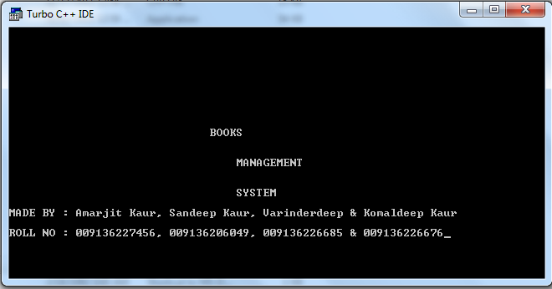

Display the menu list.

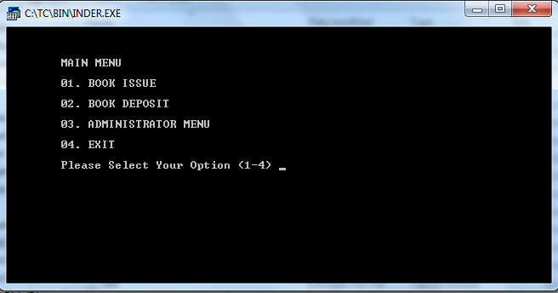

Select the option
Press no.1

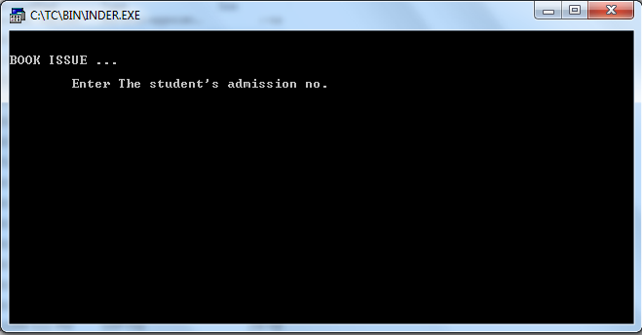

Enter the student’s admission no 1.

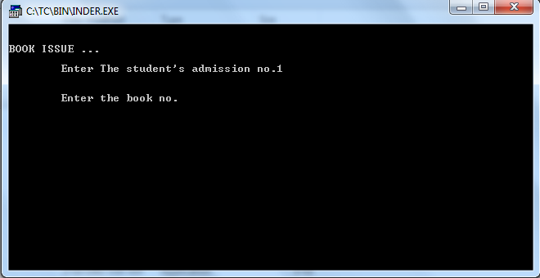

Next enter the book no 1.

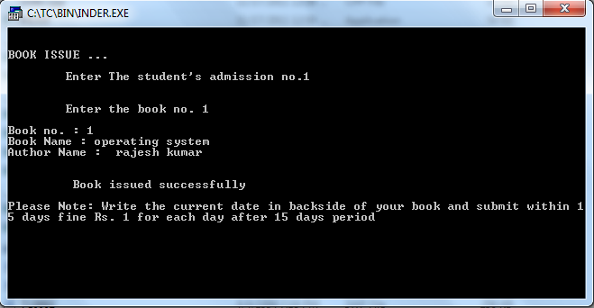

Issue the book notice .

Enter 2nd menu option.

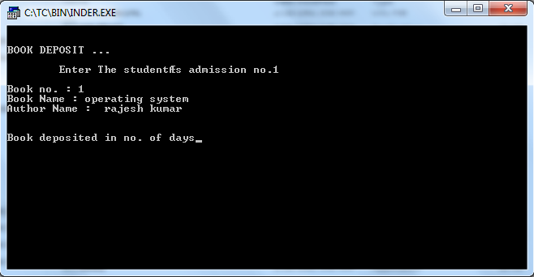

Deposited the book.

Enter the 3rd menu option.

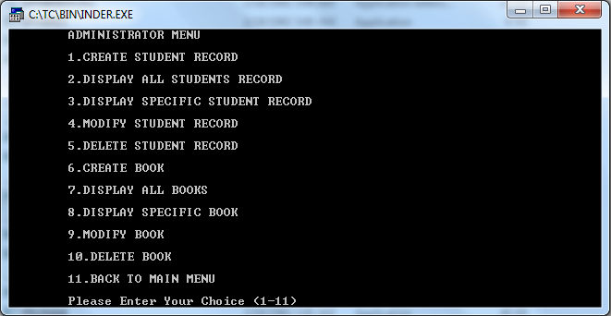

Press 1 to create the student record.

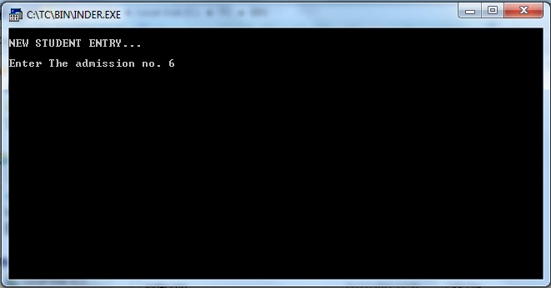

Enter the record no 6.

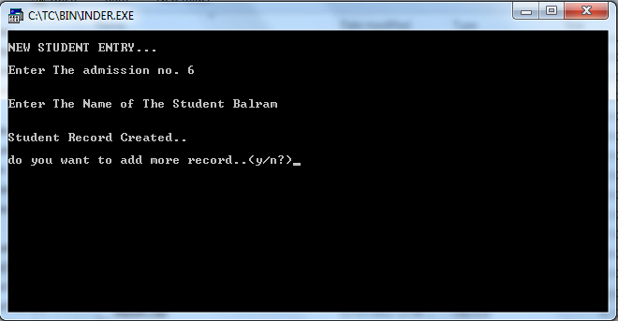

Enter the name balram .

Press 2 display all student list.

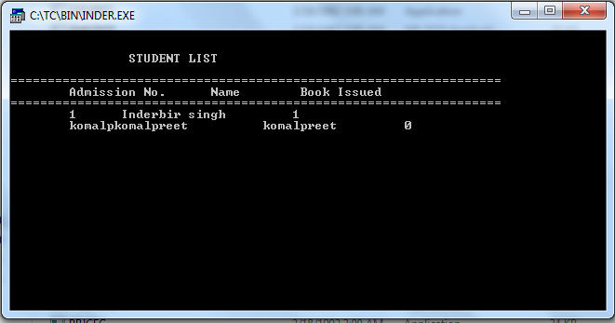

Press 3 displays the specific student.

Press the admission no.

Display student detail.

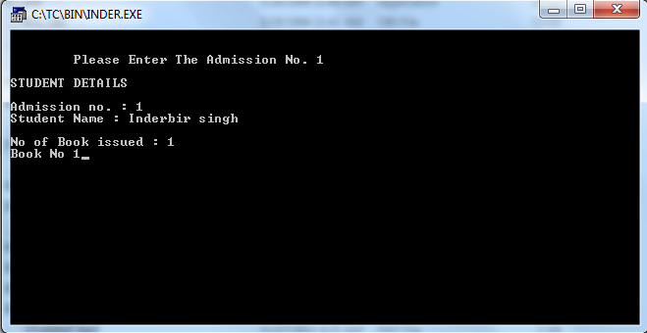

Press 4 modifies student records.

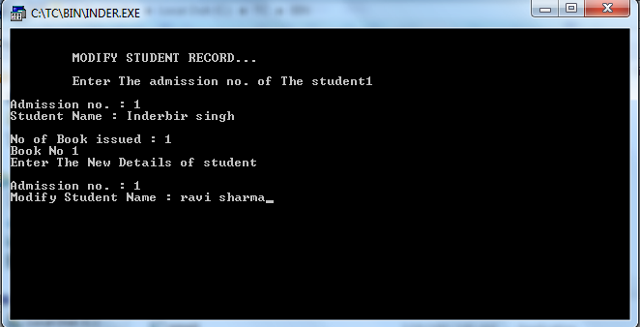

Enter the admission no.

Create new name

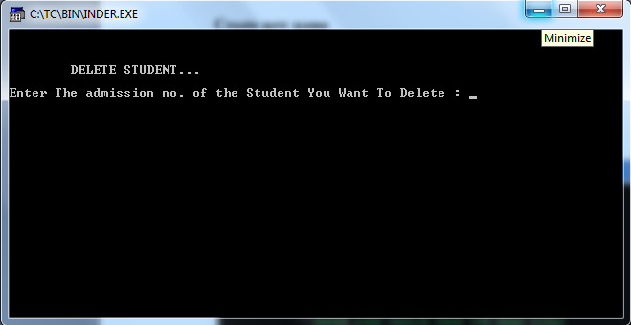

Enter the admission no.

Press the enter and delete the account.

Press 6 create the book.

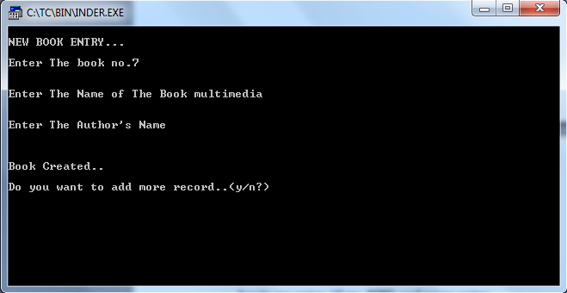

Enter the book no.

Enter the book name

Enter the author name

Press 7 to display the all books.

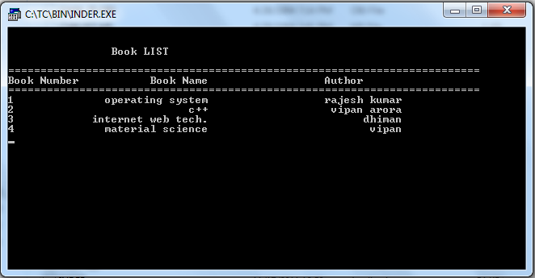

Press the 8 to modify the book.

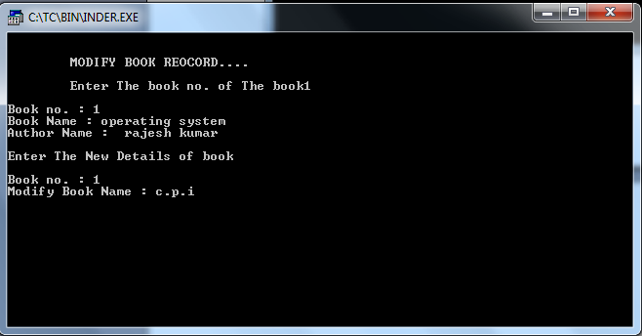

Press the delete the book records.

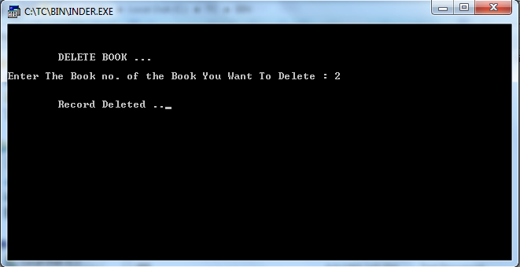

Press the 11 exit the menu.

Press ten menu options 4 to exit the project.

CONCLUSION

This project keeps the record of books It is a very simple project for handle the record of books in library. This project is time saving as it saves the time of the librarian as well as student. It reduced the paper work. The main advantage of this project is that it converts all the manual work which is time consuming and error prone to fully automated system which helps in eliminating all the paper work, saves time, improves library services.

SCOPE IN FUTURE

This project is use to keep the record of books records in the library. It is very easy to way for keeps the record of issue books. With the help of this project our time will save because about the all the books can directly view in the record. The storage enhancement provide benefit in the form of cost saving. In this project we can see easily student name, book name, date of issue and date of return. Issue books record can be save more easily. All work is done in this project with the help of choose correct option.

BIBLIOGRAPHY

- Books

- Object Oriented Programming using C++ by :-

Vipan Arora

- Object Oriented Programming using C ++ by:-

Hemant kapila.

Websites:
- www.google.com
- www.wikipedia.com

